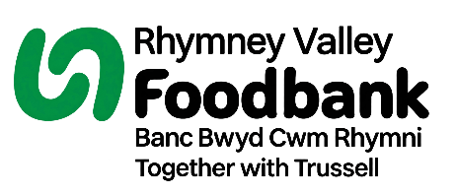
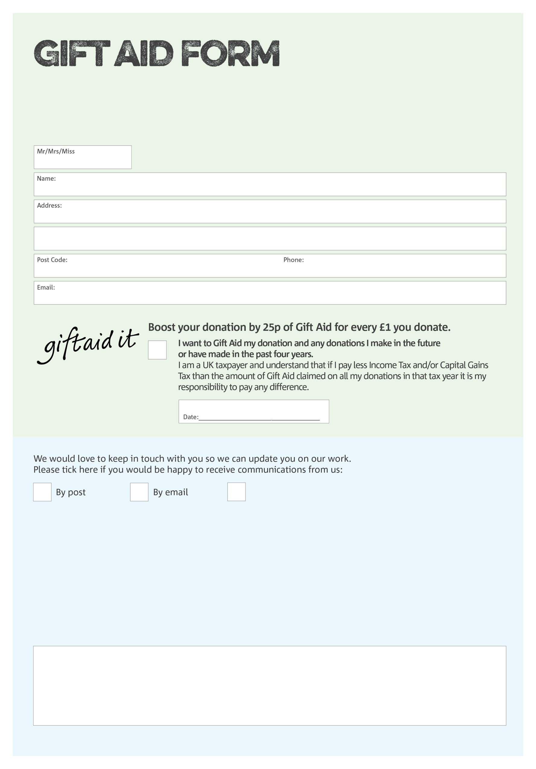
By filling in this form Rhymney Valley Foodbank will receive an extra 25p for every £1 you give at no extra cost to you. Thank you!

I do not wish to receive future communications from Rhymney Valley Foodbank
Data protection

Rhymney Valley Foodbank is committed to protecting your privacy and will process your personal data in accordance with current Data Protection legislation. Rhymney Valley Foodbank collects information to keep in touch with you and supply you with information relating to our work. To unsubscribe from our newsletter, send a message to the email address above with the word unsubscribe in the subject line. A full data privacy statement for financial donors is available from the foodbank on request.

You can change your preferences any time by contacting us on 07944354175 or emailing us at
info@rhymneyvalley.foodbank.org.uk
We would love to know why you have chosen to donate to Rhymney Valley Foodbank. If you would like to share your motivation let us know below:
Reg. Charity in England & Wales (1216538) / Elusen wedi’i chofrestru yng Nghymru a Lloegr (1216538)

